PLSQL_Exercises: Exercise 3: Stored Procedures
STEP :1
CREATE TABLE Accounts (
AccountID NUMBER PRIMARY KEY,
AccountType VARCHAR2(20),
Balance NUMBER
);

CREATE TABLE Employees (
EmployeeID NUMBER PRIMARY KEY,
EmployeeName VARCHAR2(50),
Department VARCHAR2(30),
Salary NUMBER
);
OUTPUT:
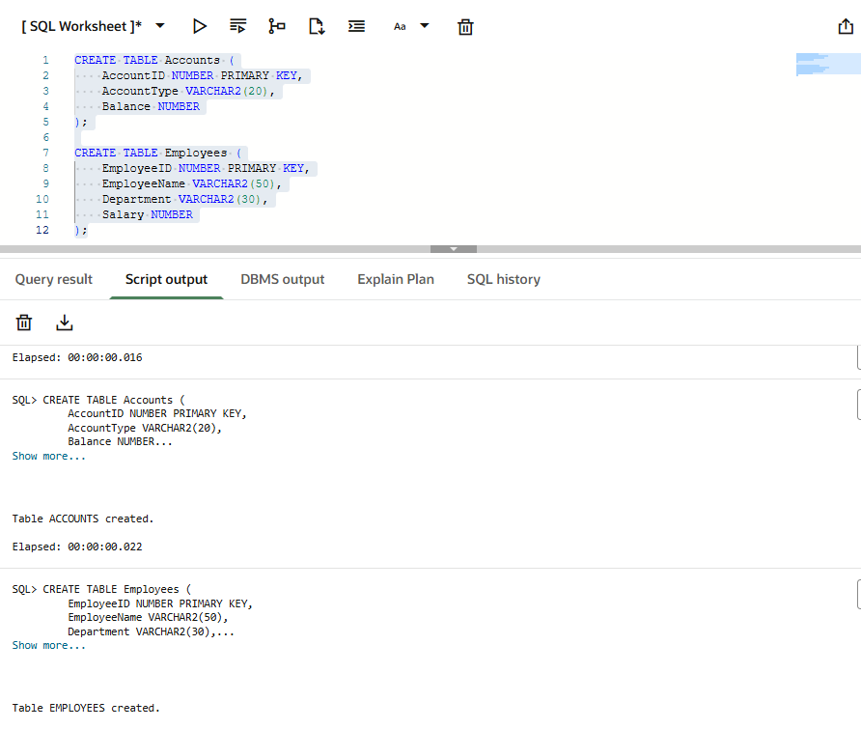
STEP : 2 INSERT THE DETAILS IN THE TABLE
OUTPUT:
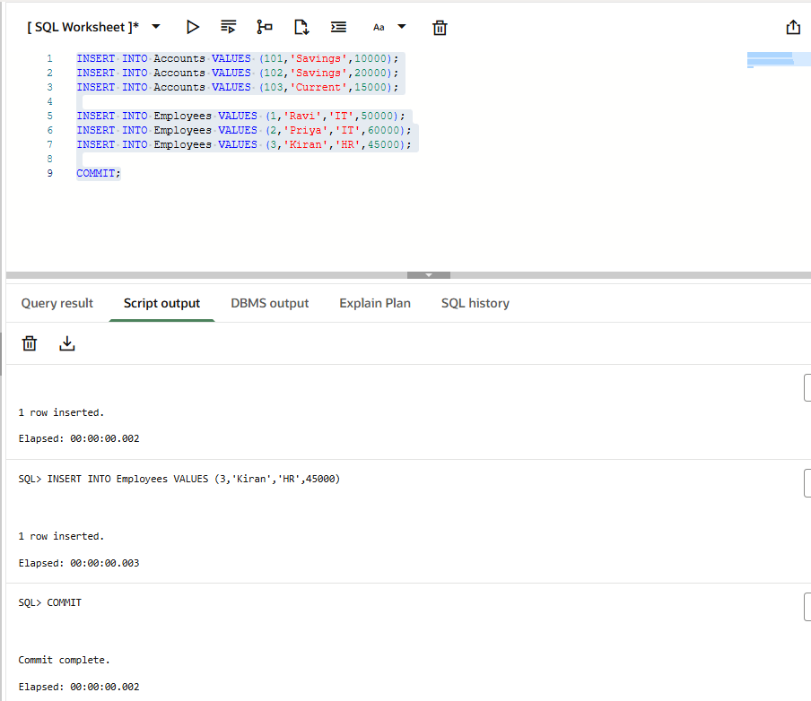
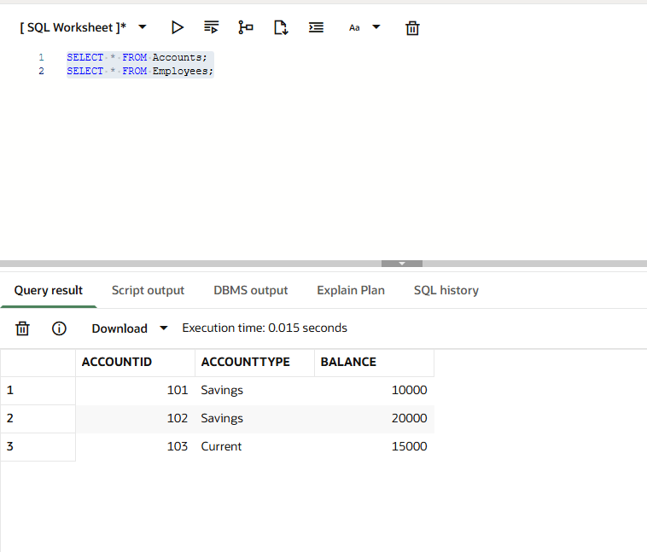
SENARIO 1:
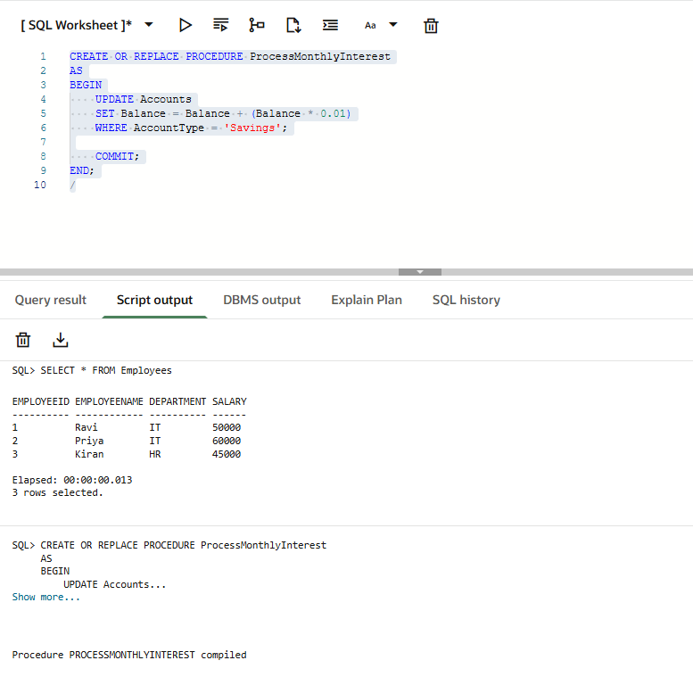
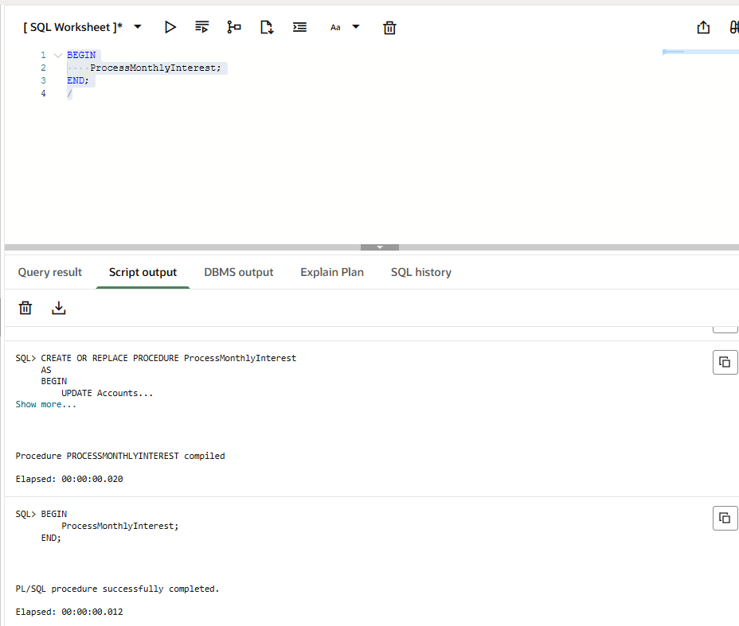
SELECT * FROM Accounts;

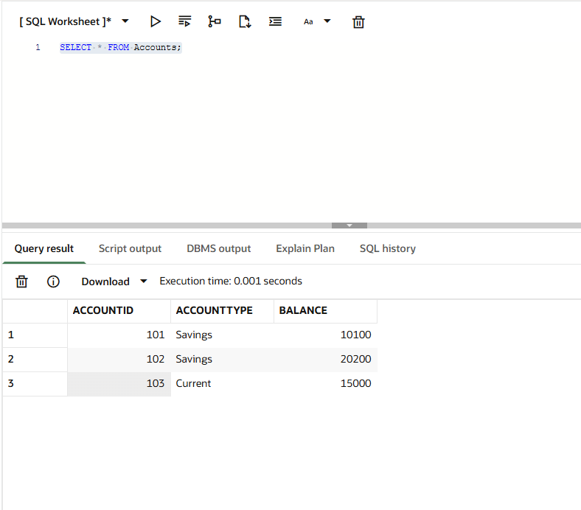
SENARIO 2:
OUTPUT:
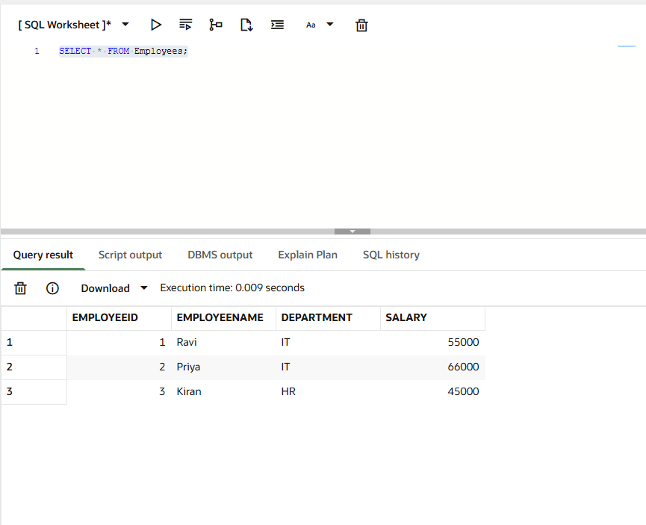
Scenario 3: Transfer Funds
CREATE OR REPLACE PROCEDURE TransferFunds(
p_from_account IN NUMBER,
p_to_account IN NUMBER,
p_amount IN NUMBER
)
AS
v_balance NUMBER;
BEGIN
SELECT Balance
INTO v_balance
FROM Accounts
WHERE AccountID = p_from_account;

IF v_balance >= p_amount THEN

UPDATE Accounts
SET Balance = Balance - p_amount
WHERE AccountID = p_from_account;

UPDATE Accounts
SET Balance = Balance + p_amount
WHERE AccountID = p_to_account;

COMMIT;

DBMS_OUTPUT.PUT_LINE('Transfer Successful');

ELSE

DBMS_OUTPUT.PUT_LINE('Insufficient Balance');

END IF;
END;
/
OUTPUT:
